**1-Problem:**

A monkey is located in a room. Suspended from the ceiling is a bunch of bananas, beyond the monkey's reach. However, in the room there are also a chair and a stick. The ceiling is just the right height so that a monkey standing on a chair could knock the bananas down with the stick. The monkey knows how to move around, carry other things around, reach for the bananas, and wave a stick in the air.

**2-The representation of the problem:**

The initial state:

1. Monkey is at door.
2. Monkey is on floor.
3. Chair is at end of the room
4. Stick is at window.
5. Monkey does not carry stick.
6. Monkey does not carry chair.
7. Bananas are still up (On the ceiling)
8. Bananas hanging in the middle of the room

state(atdoor, onfloor, atendoftheroom, atwindow, notcarrystick, not carry chair, banaup, atdoor)

**3-The goal of the game:**

canget( state( _, _, _, _, _,_, banadown, _) ).

**4-nine types of moves:**

(1) knock banana,

(2) climb chair,

(3) put chair down

(4) walk_with_chair_and_stick

(5) carry_stick,

(6) carry_chair,

(7) walk_with_stick,

(8) walk_with_chair

(9) walk (without carrying anything)

**5-A three-place relation:**

**move( State1, Move, State2)**

 move 



Ff

**“Knock” :**

move( state( P, onchair, P, P, carrystick, notcarrychair, banaup, P),

knock,

state( P, onchair, P, P, carrystick, notcarrychair, banadown, P) ).

**“climb” :**

move( state( P, onfloor, P, Z, K, notcarrychair, banaup, B),

climb,

state( P, onchair, P, Z, K, notcarrychair, banaup, B) ).

**“put_chair_down” :**

move( state( P, onfloor, P, P, K, carrychair , banaup, P),

put_chair_down,

state( P, onfloor, P, P, K, notcarrychair, banaup, P) ).

**“walk_with_chair_and_stick” :**

move( state( P1, onfloor, P1, P1, carrystick, carrychair, banaup, B),

walk_with_chair_and_stick( P1, P2),

state( P2, onfloor, P2, P2, carrystick, carrychair, banaup, B) ).

**“carry_stick” :**

move( state( P, onfloor, Z, P, notcarrystick, K , banaup, B),

carry_stick,

state( P, onfloor, Z, P, carrystick,K, banaup, B) ).

**“carry_chair” :**

move( state( P, onfloor, P, Z, K, notcarrychair, banaup, B),

carry_chair,

state( P, onfloor, P, Z, K, carrychair, banaup, B) ).

**“walk_with_stick” :**

move( state( P1, onfloor, Z, P1, carrystick, notcarrychair, banaup, B),

walk_with_stick( P1, P2),

state( P2, onfloor, Z, P2, carrystick, notcarrychair, banaup, B) ).

**“walk_with_chair” :**

move(state(P1, onfloor, P1, Z, notcarrystick, carrychair, banaup, B),

walk_with_chair(P1, P2),

state(P2, onfloor, P2, Z, notcarrystick, carrychair, banaup, B)).

**“walk” :**

move( state( P1, onfloor, Z, K, notcarrystick, notcarrychair, banaup, B),

walk( P1, P2),

state( P2, onfloor, Z, K, notcarrystick, notcarrychair, banaup, B) ).

**6-Question: can the monkey in some initial state State get the banana?**

canget( State)

canget( state( _, _, _, _, _,_, banadown, _)).

canget( State1) :-

move( State1, Move, State2),

canget( State2).

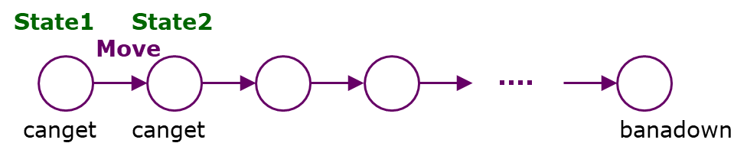

**7- Valied initial states**

1. canget(state(atdoor, onfloor, atendoftheroom, atwindow, notcarrystick,notcarrychair, banaup, atwindow)).

صورة تحتوي على نص, رسم بياني, الخط, خط يد

تم إنشاء الوصف تلقائياً

1. canget(state(atdoor, onfloor, atwindow, atwindow, notcarrystick,notcarrychair, banaup, atwindow)).

صورة تحتوي على نص, لقطة شاشة, الخط, رسم بياني

تم إنشاء الوصف تلقائياً

**8- Not Valied initial states**

1-canget(state(atwindow, onchair, atwindow, atwindow, notcarrystick,notcarrychair, banaup, atwindow)).

2-canget(state(atwindow, onchair, atwindow, atwindow, carrystick,notcarrychair, banaup, atmiddle)).